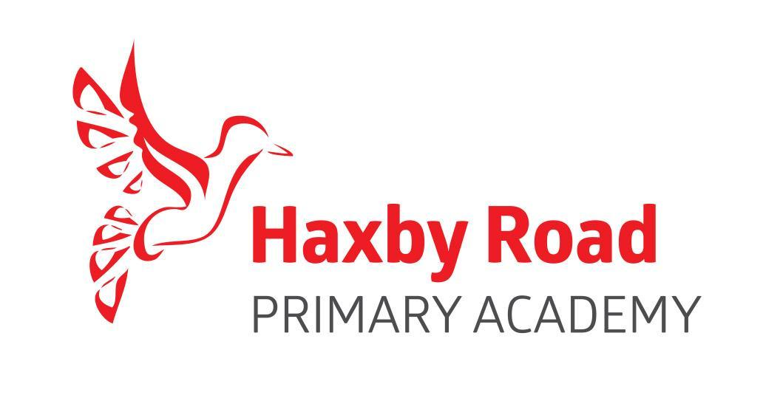
SCHOOL HOLIDAY DATES 2021/2022

Autumn Term 2021
Term starts | Tuesday 7th September
Half Term | Monday 25th October – Friday 29th October inclusive
Term ends | Friday 17th December
Spring Term 2022
Term starts | Tuesday 4th January
Half Term | Monday 21st February – Friday 25th February inclusive
Term ends | Friday 8th April
Summer Term 2022
Term starts | Monday 25th April
Mayday | Monday 2nd May
Half Term | Monday 30th May – Friday 3rd June inclusive
Term ends | Friday 22nd July

TRAINING DAYS
Monday 6th September, Friday 19th November, Friday 11th March, Friday 27th May, Monday 25th July, and Tuesday 26th July

We should remind parents there is no entitlement to additional holidays outside of normal holiday times. These should only be arranged after seeking the Head of School’s agreement.

Please Note
Year 1 Phonics Screening takes place during May 2021/June 2021.
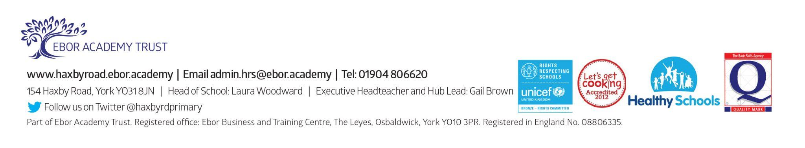
Year 6 assessments in English, Maths and Science take place during May 2021.

