Emotional Well Being Interventions Overview

Intervention | Target Year Group | Description | Duration of Intervention
Muddles, Puddles & Sunshine  Bereavement  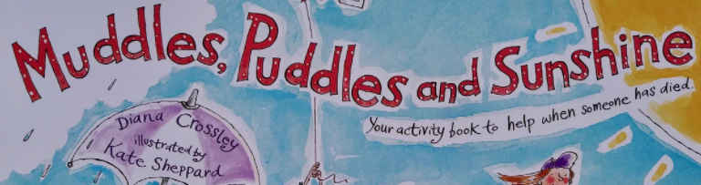 | All Year groups | This intervention is designed to help children understand more about their thoughts and feelings when someone important to them has died. In the first two weeks the child will make a memory box or jar to store items that belong to that person or memories that they shared. The following weeks will be spent creating a book about their special person which can be a great source of comfort especially for a child who is worried they may forget the person who has died. | 6 weeks  30 minutes per session  1:1
Managing our Monsters  Anger management | All Year groups | This anger intervention is designed to help children recognise their signs of anger and identify their triggers. Children will also have the time to talk openly about their anger and learn some calming strategies which will help them think of good ways of dealing with their anger. | 6 weeks  30 minutes per session  4 children
Friendships  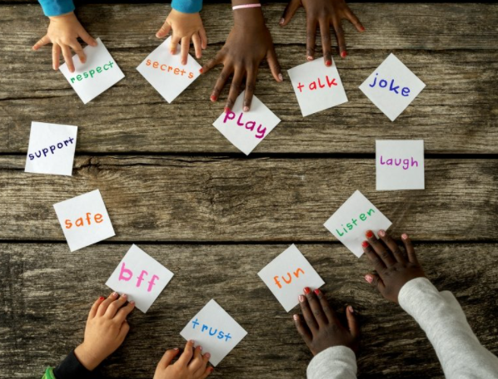 | Nursery & Reception | This intervention covers children having a sense of belonging and creating a sense of self worth. The children will cover some emotions and will also learn how to cooperate within a group. The children will also pick up basic social skills like learning how to share and be a good team player. | 6 weeks  30 minute session  4 children.
Emotional Literacy | All Year groups | This intervention covers many areas of emotional literacy. The biggest strength of this intervention is a sense of belonging it gives to the children taking part. The children will learn to be part of a group/team, look out for each other and learn to build and maintain friendships. The emotional intervention part is targeted for children struggling with emotional expression. This program will teach children emotions such as happy, sad, angry, scared, wobbly or confused. Children will identify a time in their lives when they have experienced this feeling and talk about why they have felt this way. | 6 weeks  30 minute session  4 children
Super hero workshop  Resilience | All Year groups | This workshop will help you to become your own resilient superhero. Everyone has got a superhero inside of them. The following 6 sessions will help you unleash yours. Resilience is the ability to emotionally or mentaly cope with a crisis enabling the children to return to pre crisis state quickly. When reliance exists that person uses mental processes and behaviours prompting personal assets and protecting themselves from the potential negative effects of stressors. | 6 weeks
 | Reception -  Year 2 | An intervention to recognise that sometimes everyone worries. It will help us understand that sometimes our worries take up lots of our thoughts and make us feel unsettled. When worries take over our lives it’s time to take action. The 6 activities in this booklet will help you understand and manage your worries making you feel better and more able to cope. | 6 weeks  30 minute session  4 children
Worry Workbook  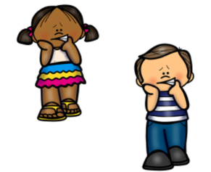 | Year 1 -2  &  Year 3 - 6 | It is really important we are aware what emotions are and how they make us feel when we are trying to manage them. The following intervention will identify week by week how we are feeling and the reason why. The group will then discuss what is making us feel this way and learn strategies to manage those feelings and worries. The children will create a well being plan at the end of the 6 week session. | 6 weeks  30 minute sessions  4 children
Year 6 Transition | Year 6 | This is designed for students in their final year of primary education getting ready to transition into Secondary School. Moving from primary school to secondary school can be imagined as a boat on its journey from river to sea. This project is a chance to think about your time at primary school and the changes ahead as you sail into secondary school. | 6 week whole class intervention
Settling your thoughts | All Year groups | To use drawing, colouring and patterns to help you to settle your thoughts. | One off whole class intervention
Alice's wonderful adventure | All year groups | This intervention is used to explain to children what might happen when arriving at the hospital for any kind of treatment. It is designed to alleviate any anxieties or preconceptions of what could happen to them. This also takes into consideration the impact COVID - 19 has had on the hospital setting | One off session of 1 hour

