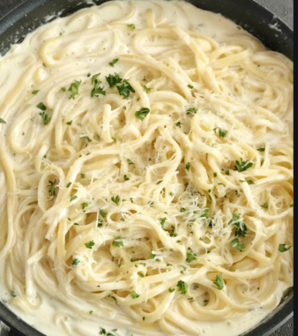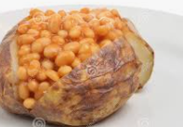

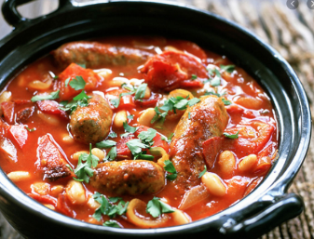

**Tuesday 13th October**

**Tomato Pasta served with mixed veg**

**Or**

**Creamy cheese pasta served with mixed veg**

**Biscuit or Fresh Fruit**

**Monday 12th October**

**Jacket Potato served with beans**

**Or**

**Jacket Potato severed with cheese**

**Ice cream tub or Fresh Fruit**

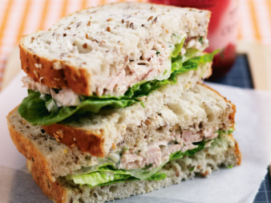

**Wednesday 14th October**

**Sausage casserole and potatoes**

**Or**

**Quorn casserole and potatoes**

**Yoghurt or Fresh Fruit**

**Thursday 15th October**

**Ham sandwich with salad**

**Or**

**Tuna and mayo sandwich with salad**

**Biscuit or Fresh Fruit**

**Friday 16th October**

**Fish fingers served with chips & peas**

**Or**

**Quorn Dippers served with chips & peas**

**Ice cream tub or Fresh Fruit**

